This is done to save one opamp for generating 1.65V (and also keeps board size smaller).
Though, the VREF is connected to 3.3V, the opamp output will still be close to 1.65V under zero current, due to the various resistor values.
Please note that the resistor values for Non-inverting pull up and feedback resistor is different, to achieve the above requirement: -

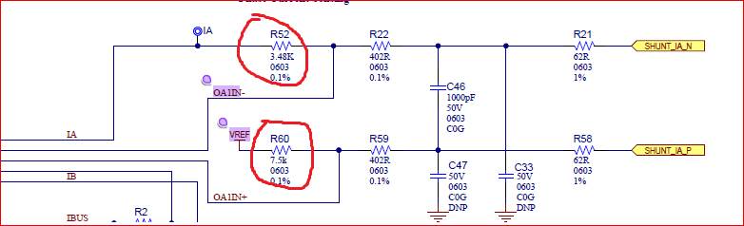

There are other combination, used by APID for the 3KW board, where the pull up for NI input of opamp is taken from in between the 2 input resistors. But due to the values of resistor, the opamp output will still be 1.65V under zero current:

